
ST ANDREW’S JUNIOR COLLEGE
Preliminary Examinations
Higher 1

Geography 8834/01
Paper 1
3 hours
Additional Materials: Insert

SUGGESTED ANSWER SCHEME

[Turn over

Section A

Cluster 2: Fieldwork

1 | A group of six junior college students, as part of their school project, wanted to investigate community response to climate change in Singapore. They decided to investigate participation in Singapore's Beverage Container Return Scheme (BCRS).  Under the BCRS, consumers pay a 10-cent deposit when purchasing eligible beverages in plastic bottles and metal cans carrying the Deposit Mark. The deposit can be recovered when the empty container is returned to a designated return point.  The students investigated the following hypothesis:  Convenience has a greater influence than concern about climate change on people's participation in the Beverage Container Return Scheme.  They selected three shopping centres in different parts of Singapore, each with a reverse vending machine (RVM). The students divided themselves into three pairs, with one pair at each site.  At each site, they:  - surveyed 30 people near the RVM using convenience sampling;  - used the same questionnaire;  - conducted the survey between 12.00 pm and 4.00 pm on one Saturday in August 2026; and  - counted the number of people using the RVM during a 30-minute period.  At the time of the investigation, the BCRS was still in its transition period. Some beverage containers in circulation did not yet carry the Deposit Mark and could not be returned for the 10-cent refund.  Resource 1 shows the locations and characteristics of the three fieldwork sites. Resource 2 shows photographs of examples of reverse vending machines in Singapore. Resource 3 shows the questionnaire used by the students. Resource 4 shows the results of the investigation.
(a) | Explain one strength and one weakness of the students' hypothesis. [4]
AO1

Award one mark for each valid strength or weakness.
Award up to an additional mark for relevant elaboration.

One strength is that the hypothesis is clearly defined and researchable because it identifies the two factors to be compared, convenience and concern about climate change, and links them to participation in the BCRS. [1] This allows the students to operationalise each variable and design appropriate instruments to collect the required data, such as questionnaire items to measure convenience and climate concern, and questions or observations to measure participation. This makes it possible to collect data that directly addresses the hypothesis. [1]

The hypothesis may not be at a suitable scale for the fieldwork undertaken. It refers broadly to people's participation in Singapore's BCRS, but the students only investigate three shopping centres, with 30 respondents at each site and data collected during a limited period. [1] The evidence may therefore be insufficiently representative to test such a broad hypothesis about participation in Singapore as a whole. [1]

(b) | With reference to Resources 1 and 2, explain the factors that the students should consider when selecting sites to investigate how convenience influences participation in the Beverage Container Return Scheme. [5]
AO1

Award one mark for each consideration.
Award up to an additional mark for relevant elaboration.

One consideration is whether the sites provide sufficient variation in convenience. The students should select RVMs that differ in factors such as accessibility, visibility and location within the shopping centre. Having sites with relatively high, moderate and low levels of convenience provides contrasting conditions. [1] This allows the students to compare whether participation changes as convenience changes, enabling the influence of convenience in the hypothesis to be tested. [1]

Another consideration is whether the sites are comparable in characteristics other than convenience. Factors such as pedestrian footfall, type of shopping centre and the characteristics of people using the area could also affect the number of people participating in the BCRS. Selecting sites that are broadly similar in these respects reduces the influence of alternative explanations. [1] This makes it more likely that differences in participation between sites can be associated with differences in convenience, allowing the hypothesis to be tested more validly. [1]

A third consideration is whether each site has sufficient footfall to obtain the required sample size. The students need enough people near the RVM to survey 30 respondents at each site. Selecting sites with adequate pedestrian activity makes it more likely that the same target sample size can be achieved at all three sites, improving the comparability and reliability of the data used to test whether convenience has a greater influence on participation. [1]

(c) | Suggest how the students could improve the accuracy and reliability of the data collected on the number of people using the RVMs. [4]
AO1

Award one mark for each suggestion.
Award up to an additional mark for relevant elaboration.

The students should first use a standardised definition of an RVM user, for example counting a person only when they actually deposit at least one eligible container. One student could count using a tally counter while the second student independently checks the count. [1] This reduces missed users or differences in how users are counted, improving accuracy. [1]

They should also repeat the 30-minute observations several times at each site, including comparable periods on different days, and calculate a mean number of users. [1] A single 30-minute count could be affected by an unusually busy or quiet period, while repeated measurements would produce more reliable results. [1]

(d) | With reference to Resource 3, explain the strengths and limitations of the questionnaire used in the investigation. [4]
AO2

Award one mark for each strength and limitation.
Award up to an additional mark for relevant elaboration.

A strength is that the questionnaire mainly uses closed questions with fixed response options, including 1 to 5 scales for convenience and climate concern. This standardises how respondents answer and reduces differences caused by students recording or interpreting responses differently, therefore increasing the reliability of the data collected. [1]

The questionnaire is also short and quick to complete because respondents mostly select from predetermined responses rather than giving lengthy open-ended answers. This makes it easier for the students to survey the required 30 respondents at each site within the limited fieldwork period, reducing the likelihood that the intended sample size cannot be achieved. [1]

A limitation is that responses about previous BCRS use and climate concern are self-reported. Respondents may forget how often they have returned containers or may give a higher climate-concern score because they think this is socially desirable. The recorded responses may therefore not reflect their actual behaviour or attitudes, reducing the accuracy of the data. [1]

A further limitation is that some fixed response categories may oversimplify respondents' behaviour. For example, asking for the single “main reason” for returning containers forces respondents to select one factor even if convenience, the deposit and environmental concern all influenced their decision. This may produce an inaccurate representation of the factors influencing participation and therefore weaken the validity of conclusions drawn from the questionnaire. [1]

(e) | Using Resource 4, describe the relationship between mean convenience score and participation in the BCRS at the three sites. [3]
AO2

Award one mark for each description.
Award up to an additional mark for relevant elaboration.

- There is a consistent positive relationship between mean convenience score and BCRS participation. [1]
- Site A has the highest convenience score of 4.4 and also the highest participation, with 73% having used the BCRS at least once and 24 RVM users observed. [1]
- Site C has the lowest convenience score of 2.1 and also the lowest participation, at 27% and only six observed users. [1]

(f) | Evaluate the validity of the students' fieldwork. [10]
AO3

Assessed using Generic Level Descriptors for H1 Fieldwork Evaluative Question
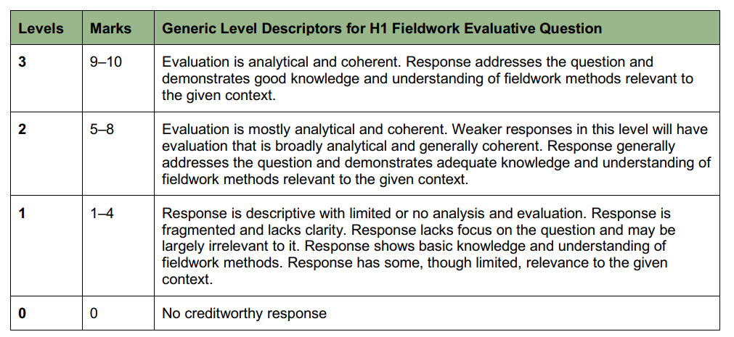

Indicative Content
Candidates should evaluate the validity of the students’ fieldwork by examining the strengths and weaknesses of the fieldwork plan and data collection, linking these to accuracy, reliability, relevance and representativeness. The focus should be on whether the methods and data provide a sound basis for investigating the relative influence of convenience and climate concern on BCRS participation. Weak responses will describe procedures without explaining their consequences for validity, focus extensively on whether the hypothesis is supported, or offer a conclusion that merely repeats the strengths and weaknesses.

Good responses would analyse both strengths and weaknesses in the context of the investigation. For example, the questionnaire directly measures convenience, climate concern and reported participation, improving relevance, while selecting three contrasting shopping centres provides potentially different convenience conditions for comparison. Standardised questionnaires, equal sample sizes and collection during the same period support reliability and comparability. Self-reported participation and observed RVM use provide complementary evidence, although they cover different timeframes and groups of people. However, conducting the investigation during the BCRS transition period weakens the interpretation of participation because people with containers lacking the Deposit Mark may be unable to participate regardless of their convenience or climate concern. The absence of a deliberate strategy to include a range of climate-concern levels also limits a fair comparison of the two factors. Candidates may explain how convenience sampling near RVMs reduces representativeness, how collection at only three shopping centres on one Saturday restricts wider applicability, and how a single 30-minute observation period and self-reported attitudes or behaviour may reduce reliability and accuracy.

The strongest responses would demonstrate effective weighing by identifying which limitations most fundamentally weaken the evidence and explaining why methodological strengths cannot fully compensate for them. Candidates should suggest at least three targeted improvements, such as repeating the investigation after the transition period, deliberately including respondents across a wider range of climate-concern levels, and extending sampling and repeated observations across more sites, days and times. Each improvement should address an identified weakness and explain how it strengthens accuracy, reliability, relevance or representativeness.

Section B

Cluster 1: Sustainable Future and Climate Change

Answer both questions.
2 | (a) | Using examples, explain one tension and one complementarity that can arise between sustainable urban development and liveability. [5]
Award 1 mark for a clear explanation of a valid tension OR complementarity that can arise between SUD and liveability.
Award 1 additional mark for any relevant elaboration OR specific example of each explanation.
Max total 5m, with a 3m max cap for either tension OR complementarity

1) Tension Between SUD and Liveability

- [1m] Explanation: When urban sustainability strategies (i.e. compact city models/ high-density living) aimed at reducing land consumption and carbon footprints (environmental aspect of SUD) negatively impact the immediate comfort, well-being and lived experience of current urban residents.

- [+1] Elaboration: Concentrating housing, commercial activities and transport infrastructure in high-density, mixed-use areas aims to maximise energy efficiency and reduce travel distances. However, this high density often leads to severe traffic congestion, noise pollution, lack of open green spaces and high crowding, which reduces perceived liveability for residents. OR
- Additionally, short-term liveability solutions (e.g. widespread air-conditioning use to mitigate urban heat) conflict with long-term environmental sustainability by driving up energy demand and greenhouse gas emissions.

- [+1m] Example: In Singapore, extensive air-conditioning use improves thermal comfort and daily liveability in a tropical climate. However, this inevitably leads to environmental tension as building/household AC accounts for ~19% of national carbon emissions.

2) Complementarity Between SUD and Liveability

- [1m] Explanation: When initiatives designed to enhance social, environmental or economic sustainability simultaneously improve the daily quality of life, health and well-being of city dwellers.

- [+1m] Elaboration: Pursuing sustainability in the short term directly enhances long-term liveability through shared spatial and environmental features. For instance, designing car-lite layouts and green buildings reduces energy consumption while natural lighting and natural airflow lower utility costs and improve indoor air quality. OR
- Furthermore, prioritising public transport and walking/cycling lowers traffic-related congestion and local air pollution while fostering stronger social interaction and community identity among residents.

- [+1m] Example: In Tianjin Eco-city, green urban design integrates walkable residential neighborhoods with recycled waste systems and solar energy. This reduces the city's overall carbon footprint while providing residents with a clean, low-noise environment and accessible public spaces that boost daily liveability.

 | (b) | Using Resources 5 and 6, explain how living conditions in Dharavi present challenges to achieving sustainable urban development in Mumbai. [4]
Award 1 mark for an explanation of how living conditions in Dharavi present challenges to achieving sustainable urban development in Mumbai.
Award a maximum of 1 additional mark for any elaboration of each explanation.
Explicit reference to R5 and 6 is compulsory to be credited full 4m.
Minimally must cover at least 2 dimensions of SUD to garner 4m.

1) Challenge to Social Well-being

- [1m] Resource Evidence & Inference:
  - R5 shows that 1 million residents are crammed into an area of just $2.5{\text{ km}}^{2}$, creating extremely high population density with ‘densely packed, tiny, self-built homes with shared sanitation facilities’.
  - In R6 (CMG & CFG), open sewage and stagnant wastewater run directly down the unpaved pedestrian alleyway where residents and children walk barefoot.

- [+1m] Elaboration: Overcrowding combined with poor sanitation infrastructure creates severe public health hazards. The exposure to open waste facilitates the rapid transmission of waterborne and infectious diseases (e.g., cholera, dysentery), compromising basic social well-being for current urban dwellers.
- Meeting the essential needs of the urban poor becomes extremely difficult, undermining intra-generational equity in Mumbai.

- [1m] Resource Evidence & Inference:
  - R6 (LBG & RMG) displays housing structures constructed from temporary, precarious materials such as rusted corrugated iron sheets and roofs made of fabric.

- [+1m] Elaboration: The structural fragility of these homes and the lack of formal drainage leave residents highly vulnerable to hazards such as fire outbreaks that can lead to compromise of social dimension of SUD due to homelessness and injuries.

2) Challenge to Environmental Integrity

- [1m] Resource Evidence & Inference:
  - R6: There is also an open drainage seen at the CFG and there are bags of waste being dumped in the open near the open drainage (CMG).

- [+1m] Elaboration: improper waste disposal directly contaminates the surrounding water bodies as toxins from the waste can seep into the drains nearby, severely compromising Mumbai’s overall environmental integrity.

3) Challenge to Economic Vitality

- [1m] Resource Evidence & Inference:
  - R6 shows extremely poor living conditions where the materials of the houses are made of corrugated metal and fabric and it is messy and disorganised.

- [+1m] Elaboration: Such poor living conditions prevent investors from creating new business opportunities and the area will continue to be poverty stricken/ people living here may fall sick easily and negatively affect their economic productivity.

 | (c) | Describe the population growth rate of Mumbai from 1901 to 2001 as shown in Resource 7. [3]
Award 1 mark for a description of the population growth rate of Mumbai from 1901 to 2001 paired with accurate data evidence (years and percentages read from the green line graph) from R7.
Answers describing total population levels should not be credited.

1) General Trend & Overall Positive Nature
- The population growth rate of Mumbai fluctuated significantly between 1911 and 2001,
- but remained generally positive throughout the entire period (ranging between 0% and 5.2%).

2) Highest Peak and Lowest Dip (Extremes)
- The lowest growth rate (trough) occurred in 1931 at 0%.
- The highest growth rate (peak) was recorded in 1951 at approximately 5.2%.

3) Stabilisation / Period of Stagnation
- The growth rate remained stable/unchanged at 1.9% from 1991 to 2001.

 | (d) | Explain why slums develop in urban areas of countries at low levels of development. [5]
Award 1 mark for an explanation of a valid reason/factor driving slum growth in urban areas of countries at low levels of development.
Award a maximum of 1 additional mark for any elaboration/ specific example of each explanation.
Response must be contextualised to urban areas of countries at low levels of development to be credited. (e.g., rapid rural-urban migration, high natural increase, lack of municipal capacity/resources)

1) Rapid Rural-to-Urban Migration Driven by Push-Pull Factors
- [1m] Explanation: Slums develop because large numbers of rural migrants move to cities in search of better economic opportunities, far exceeding the city's capacity to house them as they enter at such a rapid pace.

- [+1m] Elaboration: In countries at low levels of development, rural areas may experience severe agrarian distress (e.g., drought, poor soil fertility, lack of jobs), which acts as a strong push factor. Migrants are drawn to cities by pull factors like employment and healthcare. Because this population movement occurs at an unmanageable speed, migrants are forced to occupy vacant, informal land and construct self-built shelters forming slums.

2) Shortage of Affordable Formal Housing and Low-Income Levels
- [1m] Explanation: Extreme poverty and low wages among urban residents, combined with a severe shortage of public housing, leave low-income households with no affordable legal options.

- [+1m] Elaboration: Rural-urban migrants predominantly work in the informal sector (e.g., street vending, construction) with low and irregular incomes. Commercial housing developers tend to focus on middle-to-high-income groups (profit making), while LDC governments lack the financial resources to construct low-cost public housing. For example, in Mumbai (India), formal housing is financially out of reach for the urban poor, forcing them into informal settlements like Dharavi.

3) Weak Urban Governance and Ineffective Land Planning
- [1m] Explanation: Authorities in developing countries often lack institutional capacity, funding and enforcement power to plan, zone and manage rapid city growth properly.

- [+1m] Elaboration: Weak governance results in delayed or non-existent master planning for urban expansion. Municipalities fail to acquire land or build infrastructure (water, electricity, roads) ahead of growth. Due to poor law enforcement and ambiguous land tenure laws, informal settlements are allowed to proliferate unchecked on unzoned or marginal public land.

4) High Rates of Natural Population Increase within Slums
- [1m] Explanation: High birth rates among the young populations already living in urban areas continuously increase slum population size and density from within.

- [+1m] Elaboration: Rural-to-urban migrants in developing countries are typically young adults in their prime reproductive years. Due to limited access to family planning and healthcare in informal settlements, fertility rates remain high. This internal demographic growth causes existing slums to grow/expand outward and become increasingly overcrowded over time.

5) Occupation of Marginal, Unattractive Land
- [1m] Explanation: Slums frequently develop on hazardous, low-value land (e.g., steep slopes, riverbanks, near train tracks, near waste) because it is unwanted by formal developers and ignored by land owners.

- [+1m] Elaboration: Authorities in developing countries often lack enforcement power and have other pressing issues at hand. Because urban land prices are high, low-income groups squatter on high-risk, environmental buffer zones that are unsafe for formal construction. For example, slums often develop along polluted riverbanks (such as the Mithi River in Mumbai) or steep hillsides (such as the favelas in Rio de Janeiro), leading to informal settlements in dangerous areas.

 | (e) | Using Resource 8, explain the challenges in trying to improve the lives of slum dwellers in low-income cities, such as Mumbai. [5]
Award 1 mark for an explanation of a challenge in trying to improve the lives of slum dwellers in low-income cities.
Award a maximum of 1 additional mark for any elaboration of each explanation.
Response must be accompanied with specific reference to R8 for each explanation to be credited the mark.

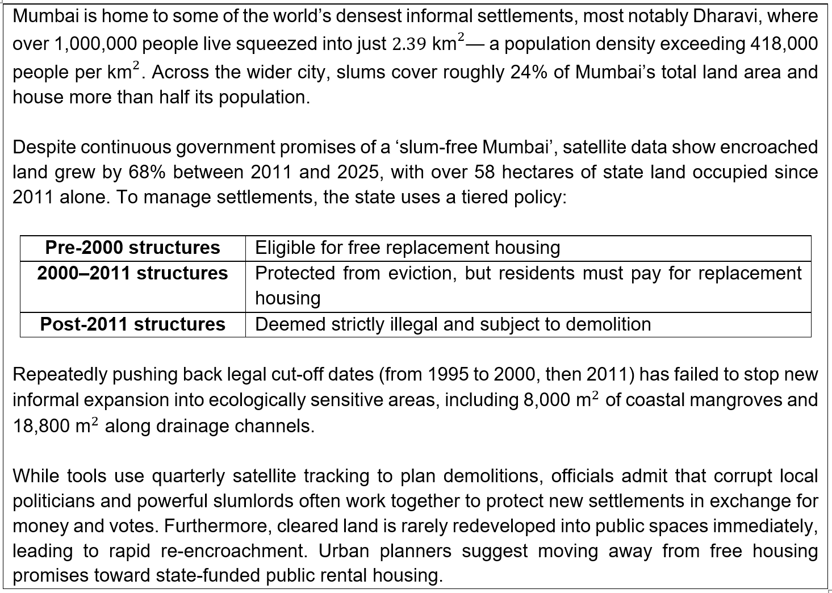

1) Extreme Population Density and Scale of Informal Settlements
- [1m] Explanation: The large spatial scale and extreme population density of informal settlements make physical intervention, housing upgrading and infrastructure provision logistically difficult for city authorities.

- [+1m] Evidence & Elaboration: R8 notes that "over 1,000,000 people live squeezed into just $2.39{\text{ km}}^{2}$" in Dharavi, with "slums cover[ing] roughly 24% of Mumbai’s total land area and hous[ing] more than half its population". Upgrading housing or building formal infrastructure in such congested conditions requires mass relocation, which causes social displacement and faces severe physical space constraints.

2) Complex Tiered Housing Policies and Policy Incentives
- [1m] Explanation: Policy mechanisms such as cut-off dates for legal protection create exclusionary criteria that leave many residents ineligible for formal housing, while encouraging continuous informal expansion.

- [+1m] Evidence & Elaboration: Resource 8 outlines a tiered policy where pre-2000 structures receive "free replacement housing", 2000–2011 structures require residents to "pay for replacement housing", and post-2011 structures are "deemed strictly illegal and subject to demolition". "Repeatedly pushing back legal cut-off dates (from 1995 to 2000, then 2011)" incentivises dwellers to build new informal structures in hopes of future policy pardon, causing "encroached land [to grow] by 68% between 2011 and 2025".

3) Corruption and Political Patronage Networks
- [1m] Explanation: Institutional corruption and vested political interests actively undermine urban redevelopment efforts and law enforcement.

- [+1m] Evidence & Elaboration: Resource 8 highlights that "corrupt local politicians and powerful slumlords often work together to protect new settlements in exchange for money and votes". This political-slumlord nexus hampers eviction or upgrading plans, as politicians rely on informal settlements as vote banks and income sources.

4) Re-encroachment
- [1m] Explanation: Delayed site development leads to immediate re-settlement after land clearing. This poses as a challenge to improve the lives of slum dwellers because efforts to improve keep getting disrupted.

- [+1m] Evidence & Elaboration: Resource 8 states "cleared land is rarely redeveloped into public spaces immediately, leading to rapid re-encroachment" this neutralises government efforts to clear land.

3 | Resource 9 shows changes in temperature and atmospheric carbon dioxide concentration over the past 800,000 years. Resource 10 shows the contribution of human and natural factors to observed global warming. Resource 11 shows projected global surface temperature change under three future emissions scenarios.
 | (a) | Using Resource 9, describe the relationship between changes in temperature and atmospheric carbon dioxide concentration over the past 800 000 years. [3]
AO2
Award 1 mark for each valid description.
Award up to an additional mark for elaboration (where applicable).

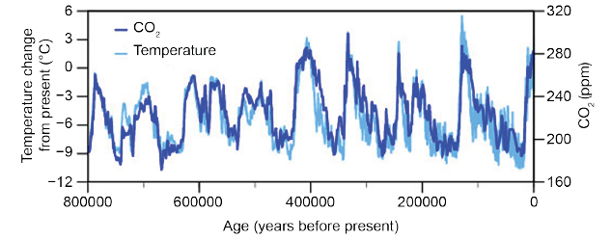

- There is a positive relationship between atmospheric CO₂ concentration and temperature. OR Periods of high CO₂ concentration generally correspond with higher temperatures, while periods of low CO₂ correspond with lower temperatures. [1]
- For example, around 400,000 years before present, CO₂ concentration rose to approximately 280 to 300 ppm while temperature was above the long-term average, whereas during colder periods CO₂ fell towards about 180 to 200 ppm. [1]
- Both variables also show repeated fluctuations over the 800,000-year period rather than a continuous rise or fall.[1]

 | (b) | Explain how natural factors may cause changes in global temperature. [6]
AO1
Award 1 mark for each valid explanation.
Award up to an additional mark for elaboration (where applicable).
Award maximum of 4 marks for responses that do not discuss feedback loops.

Changes in solar output can change the amount of solar insolation Earth receives.
- Changes in solar output, associated with variations in solar activity, can alter the amount of incoming short-wave radiation reaching Earth. [1]
- Higher solar output increases the amount of energy entering the climate system and can raise global temperatures, while lower solar output can contribute to cooling. [1]

Changes in the Earth's orbit can change the distribution of heat, potentially triggering the growth or retreat of ice sheets
- Changes in the Earth's orbit, axial tilt and precession alter where and when solar energy is received rather than simply changing the total amount received. [1]
- For example, reduced summer insolation at high northern latitudes means that less winter snow melts during summer. Snow can therefore accumulate over successive years, allowing ice sheets to develop. [1]

Ice-albedo feedback can act as feedback mechanisms that amplify an initial temperature change
- Once ice sheets expand, the ice-albedo feedback reinforces cooling. Ice and snow have a high albedo and reflect more incoming solar radiation back to space, reducing the amount absorbed by Earth's surface. [1]
- This causes further cooling and encourages further ice-sheet growth. Conversely, melting ice lowers albedo and amplifies warming. [1]

 | (c) | With reference to Resource 10, explain why human activities are considered the main cause of contemporary climate change. [5]
AO2
Award 1 mark for each valid explanation.
Award up to an additional mark for elaboration (where applicable).
Award maximum of 3 marks without reference to Resource 10.

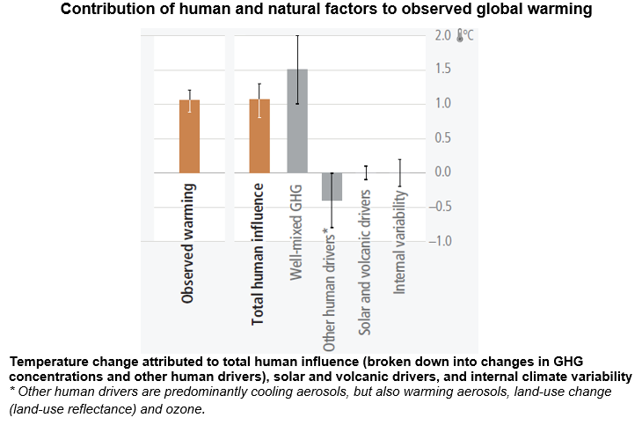

- R10 shows that observed warming is approximately 1.1°C, which is very similar to the warming attributed to total human influence. [1]
- In contrast, the contributions from solar and volcanic drivers and internal climate variability are centred close to 0°C. This means natural factors cannot account for the magnitude of observed contemporary warming. [1]

- The largest positive human influence comes from well-mixed greenhouse gases, which contribute about 1.5°C of warming. Human activities such as burning fossil fuels increase atmospheric concentrations of carbon dioxide, while agriculture, waste and energy production also release greenhouse gases such as methane. [1]
- These gases absorb outgoing long-wave radiation and strengthen the enhanced greenhouse effect. [1]

- Resource 10 also shows that other human drivers produce a net cooling effect of about 0.4°C, mainly because aerosols reflect incoming solar radiation. However, this cooling only offsets part of greenhouse-gas warming. The net effect of human activity therefore remains close to the observed rise in global temperature, providing strong evidence that human activity is the main cause of contemporary climate change. [1]

 | (d) | Using Resource 11, compare the projected global surface temperature change under the three emissions scenarios. [4]
AO2
Award 1 mark for each valid benchmark.
Award 1 mark for each comparison.
Award maximum of 2 marks for answers with only similarities or differences.

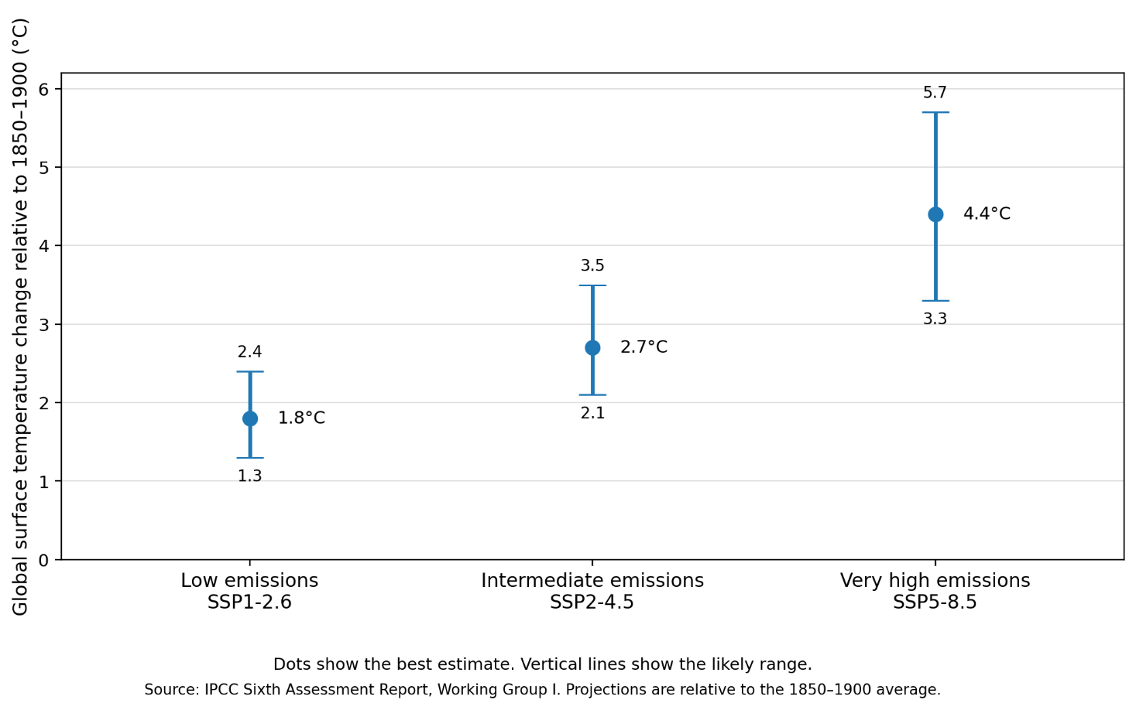

- In terms of the direction of temperature change, all three emissions scenarios are similar [1] because they project an increase in global surface temperature relative to 1850–1900. Even under the low-emissions scenario, the best estimate is a warming of 1.8°C. [1]

- In terms of the magnitude of projected warming, the scenarios differ, with greater warming projected under higher-emissions scenarios. [1] The best estimate increases from 1.8°C under the low-emissions scenario to 2.7°C under the intermediate-emissions scenario and 4.4°C under the very-high-emissions scenario. [1]

- In terms of the likely range of warming, all three scenarios are similar because each has a range of possible temperature outcomes rather than a single certain value. [1] However, the ranges differ in their values: approximately 1.3–2.4°C under low emissions, 2.1–3.5°C under intermediate emissions and 3.3–5.7°C under very high emissions. Hence, the likely range also shifts towards greater warming as emissions increase. [1]

 | (e) | With reference to Resource 11, explain two reasons why there is uncertainty over the extent of future global warming. [4]
AO2
Award 1 mark for each reason.
Award up to an additional mark for elaboration (where applicable).

- One reason is uncertainty over future greenhouse gas emissions. Future emissions depend on factors such as economic development, energy use and the extent to which countries implement mitigation strategies. [1]
  - Resource 11 therefore presents different emissions pathways, with best estimates ranging from 1.8°C under low emissions to 4.4°C under very high emissions. Future warming cannot be known precisely because it is uncertain which emissions pathway society will follow. [1]

- A second reason is uncertainty over how strongly the climate system will respond to a given level of emissions. Feedback processes, including changes in water vapour, ice and carbon sinks, may strengthen or weaken the initial warming and are not perfectly understood. [1]
  - This is represented by the likely range within each scenario. For example, even under the very-high-emissions scenario, warming could range from approximately 3.3°C to 5.7°C, rather than having a single certain outcome. [1]

Section C

Cluster 1: Sustainable Future and Climate Change

Answer two questions.

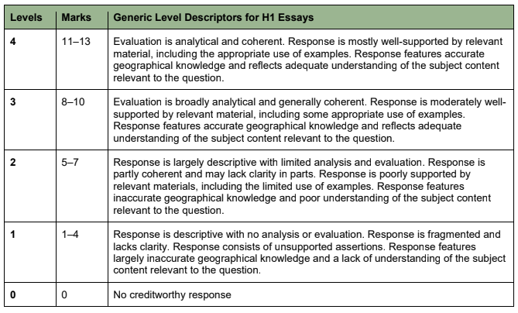
4 | ‘Urban liveability is mainly affected by economic factors.’  Evaluate this statement. [13]
Indicative content:

Candidates should weigh economic factors against environmental and political/social factors to judge whether economic factors are truly the "main" influence on urban liveability, using benchmarks such as whether the factor affects all urban dwellers (scale), whether it drives other factors (causal primacy), and whether its importance holds across different places. Economic factors (income, property values, socio-economic status) do shape liveability significantly and can be argued as having causal primacy, since wealth often determines the quality of housing, environmental conditions, and infrastructure access a resident enjoys. However, claiming economic factors are the ‘main’ factor is likely an overstatement, since urban liveability is inherently subjective and relative to place, time and the assessor's values.

Good responses would show that the significance of economic factors is not universal but shifts across people (e.g. women may prioritise fear of crime over income; the elderly may prioritise social inclusion; migrants may prioritise social acceptance over economic standing), across place (economic factors may dominate in stable, well-governed cities like Singapore, but environmental hazards like flooding may override economic considerations in climate-vulnerable, weakly-governed cities such as coastal Bangladesh), and across time. Weak responses may discuss economic, environmental and political factors in silo without weighing them against the specific benchmark of "mainly," and make universal, unqualified claims without recognising that liveability is a relative, person- and place-dependent construct.

5 | ‘States play the most crucial role in responding to contemporary climate change.’  Evaluate this statement. [13]
Indicative content:

Candidates could approach the question by making a judgement on whether states truly play the most crucial role in climate change response. Candidates should establish benchmarks for assessing what ‘most crucial’ means (i.e. regulatory authority, capacity to mobilise large-scale sustained funding, ability to coordinate other actors, etc.). Poor response will simply describe state actions. Candidate can analyse the interdependence between states, firms and NGOs: states rely on firms to deliver mitigation technology and scale up implementation, while relying on NGOs to reach vulnerable communities where state capacity or reach is limited. Candidates could also evaluate how firms may prioritise profit over climate action and how NGOs, though effective at grassroots delivery, lack the authority and funding scale of states, thus states may be needed to set the regulatory and financial conditions that enable firm and NGO action in the first place. Good responses would recognise that each actor has its own unique strengths and purpose in different aspects of climate response (e.g. states for regulation and coordination, firms for innovation and scaling, NGOs for grassroots delivery and advocacy), rather than treating one as superior universally. Good responses would also recognise that the extent to which the state's role is ‘most crucial’ varies by place, depending on government capacity and political will. Hence, the statement will hold more strongly in high-capacity contexts than in constrained ones.

6 | Evaluate the impact of rapid urban population growth on progress towards sustainable urban development. [13]
Indicative content:

Candidates should evaluate the impact of rapid urban population growth by considering both its nature (positive and negative) and its type, examining effects across the three SUD dimensions (economic vitality, environmental integrity, and social well-being). On economic vitality, rapid growth can be positive, as cities offer larger job markets and higher wages, driving economic dynamism. On environmental integrity, rapid growth typically strains resources (food, energy, water) and increases waste, overcrowding and emissions, though denser cities can sometimes have smaller per capita footprints than sprawling ones. On social well-being, rapid growth strains healthcare and infrastructure and can worsen overcrowding and slum formation but may also improve relative access to education and services compared to rural areas.

Good responses will explore why the impact type and extent varies spatially. Rapid urban population growth is concentrated in developing regions (Asia and Africa, contributing ~90% of global urban population growth by 2050), where weaker governance, infrastructure and financing mean negative environmental and social costs are more severe and harder to mitigate. In developed cities with slower growth but stronger institutional capacity, negative impacts are better managed, though these cities instead face challenges (industrial pollution, emissions) tied to their development level rather than growth rate. A reasonable conclusion could be that rapid urban population growth is not inherently/automatically detrimental to SUD; its impact is contingent on the governance capacity, financing and existing infrastructure of the urban area experiencing it.

